 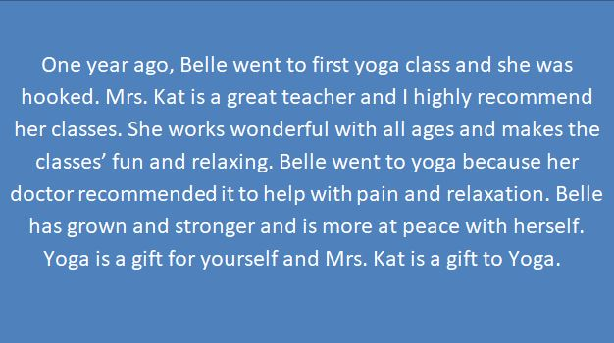

Kat has been opening her heart and sharing her beautiful practice with me for some time now.. from local studios to workshop yoga and now into her own place to practice! She knows just how to read her students and can adjust the flow or class to fit everybody's needs. Yoga isn't just about stretching and exercising your body but incorporating your heart and soul into your practice. Kat has the perfect techniques to keep you interested in exploring your mind and life while on your mat, all while you're getting your heart rate up and even breaking a sweat! Her practice is challenging but easily modified with her help to fit all levels! Her enthusiasm towards yoga and a healthy lifestyle is inspiring, and you deserve to treat yourself to her class!

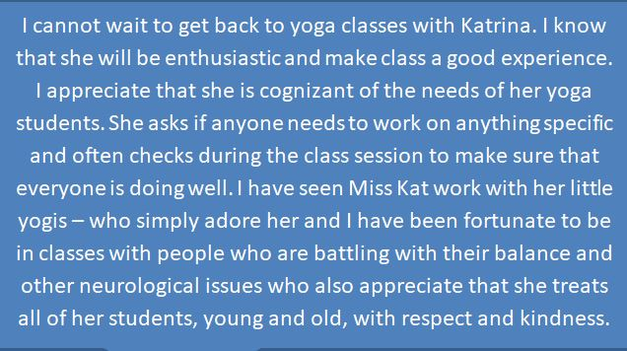  



If you are looking for a fun way to incorporate health and wellness into your child’s life then Miss Kat’s yoga class is for you! My children absolutely adore Miss Kat and look forward to her yoga class. They have learned breathing techniques to help calm and relax themselves and fun ways to do yoga poses. I have had the opportunity to watch Miss Kat teach my children and others, her love of children and yoga goes above and beyond anything I could ever imagine. My kids and I can’t wait to start taking classes with her again!

Any chance you get to take a yoga class from Kat; you shouldn’t hesitate to do so. She is committed to giving a well-rounded class that allows you to strengthen, stretch, breath, and just let go. Kat provides a relaxing, and sometimes fun, environment with no judgement, where you are free to make mistakes, ask questions, and grow together. She is knowledgeable in the multifaceted world of healthy living, so she knows what the body and mind need. On top of that she is SO GREAT with kids. My two children, 8 and 4, love going to her yoga classes where they can strengthen their yoga practice, have fun with dancing and games, and learn how to quiet their minds. My children have missed her classes terribly, but in the meantime have used her teachings at home and on the go. We are thrilled she is able to bring her practice back to us, and doing so in her own way that is true to herself and honoring what she hopes to bring to her community.