GRACE UMC, LASalle IL 61301

October 2022 NEWSLETTER
PASTOR:
Rev. Dr. Solomon Sudhakar, PhD
solomonsudhakar@yahoo.com
773 936 8979

OFFICE ADMINISTRATOR:
Gina Locati

Grace United Methodist Church
1345 Chartres Street
LaSalle, IL 61301

Phone: 815 223 1001
Email: gracelasallechurch@gmail.com
Website: gracelasalle.com

Office Hours:
Monday – Friday 8am – 4 pm

Worship Times
Sunday 9:00 AM

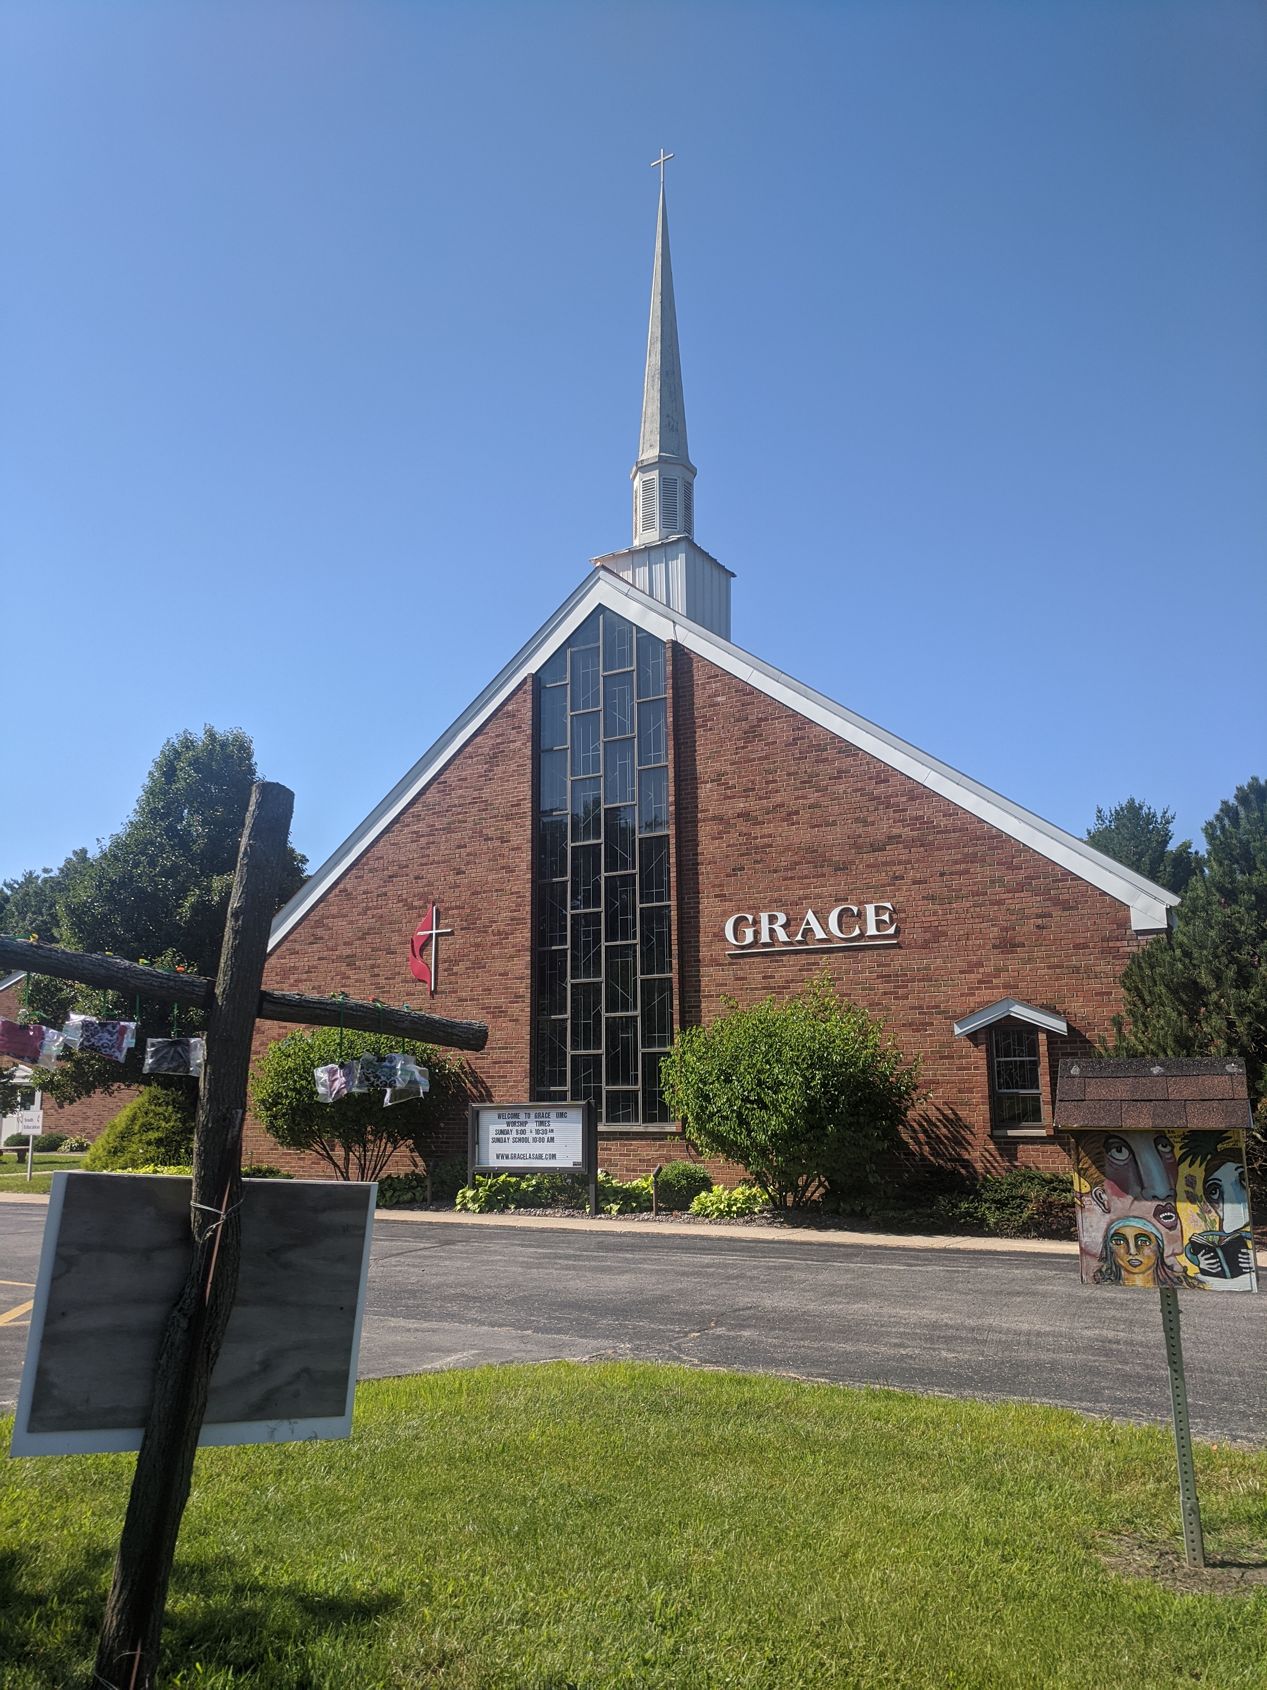

Then you will call, and the Lord will answer;
you will cry for help, and he will say: Here am I.
Isaiah 58:9 (NIV)
Dear Friends:
Greetings to you all in the name of our LORD Jesus Christ!
The month of October is here already. Change is happening all around us. Change and beauty are all around – Be still and let God speak to you through God’s wonderful creation! Months of toil and nurturing the farms, fields, and gardens are bringing forth fruit. The creation of God across the landscapes and mountains are displaying the spectrum of amazing colors. As we look out from our windows we see constant activity of the leaves falling and the birds singing. I also see the busy squirrels trying to stock up for the winter – digging ground and hiding nuts. Fall is here!

Seasons may change, circumstances in your life may change but the promises of God for you may not change. The faithfulness and the eternal love of our loving God for you and for me remains unchanged. The scripture above reminds us and encourages us to call upon the LORD in all changing circumstances of our lives, only to remind us the most profound assurance of our God saying, “Here I am”. My prayer for each of you today is that you feel and experience the presence of our loving God in your own life and in our collective life together here at Grace UMC.

As your Pastor, I take this opportunity to acknowledge and appreciate each and every leader of this church for their committed leadership and sincere fulfillment of their ‘calling’ to the ministry of the Church. I commend you all for taking time and effort in spite of your personal responsibilities for the well-being of our Church. I am amazed by your ownership and commitment for the Church. Continue the good work! I am learning a lot from all of you. The Nominations Committee will be meeting soon and as the Church approaches you for your participation and ministry, I encourage you all to respond to your Call with gladness. I hope and believe that you will come forward gladly to use your talents and gifts for the glory of God.

At church exciting things are happening. The Choir is transforming every worship service. Those who have missed attending church services due to covid-19, or traveling and sports, etc, please decide to come back to our worship services – be blessed and be a blessing for others. In the Adult sessions, we are following the book Sermon on the Mount by Amy J Levine. We are together learning and understanding the profound meaning and significance of the Sermon that Jesus has preached to us.

All of the Committees are busy preparing Reports for the upcoming Annual Church Conference on October 25^{th,} 2022. I encourage all of you to please come for this once-a-year conference of our church at 7 pm.

At the parsonage, the Trustees got few things accomplished. A new dishwasher is installed, the annual inspection of the parsonage is done, the Trustees found few things that need to be addressed. Water testing is done and the cleaning of the vents is advised by the professional as it was never done for this house in a very long time. Trustees are still working out with contractors to install a second shower in the parsonage basement. I also heard that someone generously donated for this purpose, thank you! The church might use more donations in order to complete this project. The parsonage is your house and you are welcome anytime to visit and check on us as we stay here as your pastor’s family. The pastor’s family appreciates and thank each of you for all this work and trying to give us a good stay at your parsonage house, while I serve you as your Pastor.

Finally, continue to pray for each other and for all the ministries of our church. And please pray for our denomination. I recently came across a church sign that I like to share it with you in this letter. It speaks a lot!

C H _ _ C H
U R missing from the CHURCH!

I wish and pray that we come together in worship bringing glory to God and to build one another to be as channels of the Good News of Christ in this world. God Bless!

Pastor Solomon
solomonsudhakar@yahoo.com
sudhasolomon@gmail.com
773 936 8979

OCTOBER 2022 LECTIONARY READINGS FOR SUNDAY SERVICES

2 October 2022
THEME: Rekindle the Gift / Not Ashamed
SEVENTEENTH SUNDAY AFTER PENTECOST
Lamentations 1:1-16
Psalm 137 (UMH 852)
2 Timothy 1:1-14
Luke 17:5-10

9 October 2022
THEME: Present Yourself to God / Not Ashamed
EIGHTEENTH SUNDAY AFTER PENTECOST
Jeremiah 29:1, 4-7
2 Timothy 2:8-15
Psalm 66:1-12 (UMH 790)
Luke 17:11-19

16 October 2022
THEME: Itching Ears / Not Ashamed
NINETEENTH SUNDAY AFTER PENTECOST
Jeremiah 31:27-34
Psalm 119:97-104, or Psalm 19 (UMH 750)
2 Timothy 3:14-4:5
Luke 18:1-8

23 October 2022
THEME: Poured Out / Not Ashamed
TWENTIETH SUNDAY AFTER PENTECOST
Joel 2:23-32
Psalm 65 (UMH 789)
2 Timothy 4:6-8, 16-18
Luke 18:9-14

30 October 2022
THEME: Man Out On a Limb / Face to Face with Jesus
TWENTY-FIRST SUNDAY AFTER PENTECOST
Habakkuk 1:1-4; 2:1-4
Psalm 119:137-144
2 Thessalonians 1:1-4, 11-12
Luke 19:1-10
Psalm 91:1-6, 14-16 (UMH 810)
1 Timothy 6:6-19
Luke 16:19-31

GRACE UMC/SUMMIT NEWS / HAPPENINGS

“For everything, there is a season and a time for every
matter under heaven.” Ecclesiastes 3:1

Seasons

Spring, is the season of renewal - when all is fresh and new - the world
reborn with green grass and budding trees. The birds return to build their
nests and fill them with eggs and the promise of new generations. The
world is alive with fresh sights and sounds to behold.

Then the spring gives way to summer. Summer bursts in with sun and
warmth. Its heat makes all life search for relief. The land becomes dry and
the trees and plants send down their roots searching for water. Summer
rains come bringing much-needed drink as the world soaks it up - that life-giving well, making all green and fresh once again. Then the heat of
summer begins to fade opening up to the arrival of fall.

Fall comes along bursting with color as the leaves on the trees dawn
bright reds, golden yellows, fire oranges, deep purples, grass greens, and
rich browns. There also comes crispness in the air as weather turns
cooler. The fields of harvest become fields of openness allowing the eye to
travel far across the land. As fall days shorten the world prepares to
hibernate for the winter to come.

One day when we least expect it winter comes blowing its’ cold, cold
winds across the ground, scattering snowflakes all around and bringing
with it the frost of its breath. Deep in winter, there are piles of snow and ice
upon the branches. Winter makes us dream of and long for the warmth of
spring.

Each in their own time the seasons come and go. They bring something
special to help us remember and appreciate the season that came before.
In the seasons there is always something new – something to look forward
to – a change and renewal.

Each of the Seasons – spring, summer, fall, and winter brings
something unique to the world.

Elizabeth Schuetz

NATIONAL FIRE PREVENTION MONTH
October is National Fire Prevention Month and that means it’s time for us all to take the precautionary steps to prevent dangerous and life-threatening fires.
According to the National Fire Prevention Association, the winter months see an increase in home fires, deaths and injuries. These are the months when we turn on the heat to keep our homes warm. While we need to keep our homes warm, there are steps we should take to prevent a fire.
- Make sure your heating source is well maintained. Whether it’s a fireplace, wood stove, a furnace or electric heat, check the equipment before using or have them serviced.
- Don’t store items near your heating source. Boxes, clothes, and other fuels may ignite if they are close.
- Make sure draperies and furniture and other combustible items are kept far enough away from a heating source.

October is Pastor Appreciation Month! Please take a moment to acknowledge and thank Pastor Solomon during the month of October!

Veterans Day- In Honor of Veterans Day, Let us remember those that have sacrificed so much to serve our Country. Let us keep them in our Prayers on Veterans Day and always. Help us to acknowledge those that have and continue to serve by bringing in a Picture of a loved one or friend please add their, Name, Rank, and Branch to the office so we can display these proudly on the bulletin board outside the main Church Office. These will be returned to you after Veterans Day.

Trunk or Treat- Summit will be hosting our annual Trunk or Treat on Monday, October 28th from 9:30 AM-11 AM in the Grace United Methodist Church parking lot. If you would like to participate, we ask please remember that we are a peanut-free school, and treats should contain no peanut products. We ask that participants please be in the church parking lot by 9:45 am.

"Change for Change"- Bring your coins to Church this Sunday and leave them in the "Change for Change" bucket in the foyer. If you prefer, just drop $1.00 in the "Change for Change" bucket. Thanks to your July contributions, $60.00 was added to support the Grace Missions. That's 6000 pennies!
Dry Pantry/ Winter Warmth - Thank you all for making this such a successful ministry! We are helping so many families with our donations daily! We currently have helped over 2,000 people since this ministry has begun! THANK YOU! Donations needed are blankets, new socks, boots, and Children's coats. Dry Pantry donations of, Hamburger Helper, Instant potatoes, Pasta Sauce, Pasta, cereals, Tuna, spaghetti-o's, crackers, dish soap, Laundry soap, body soap, along with toothbrushes and toothpaste.

2022 Church Conference- We will be holding our annual Church Conference on Tuesday, October 25th, 2022 at 7:00 PM. Staff Parish will meet with the DS at 6:30 PM on October 25th. More information will be given closer to the conference date.

Wednesday Evening Service- Services have begun! Join us every Wednesday at 5:30.

Bible Study-Join Pastor Solomon Sunday morning, after Fellowship, starting Sept 25th, for Sermon on the Mount, A beginner’s guide to the Kingdom of Heaven. In this Sermon on the Mount video Bible study, Dr. Amy-Jill Levine explores the most popular sermon ever delivered. In this six-session study, you’ll discover a solid historical understanding and theological context on Matthew 5-7 through Dr. Levine’s engaging teaching. This DVD is designed to be used with the Sermon on the Mount book. Books are available in the Church office for 15.00 each.

Boggio’s Fundraiser- Can you help Summit raise some Dough?- Summit is selling Apple Cider Donuts from Boggio's! 10.00 Per Dozen. Order forms are on the table outside the Church Office. You can turn the forms in any time before Oct 14th. They will be delivered to the Church shortly after and communication will be sent as soon as we know a date. Checks can be made out to Summit Learning Academy. Thank you for your support!

"Change for Change"-Bring your coins to Church this Sunday and leave them in the "Change for Change" bucket in the foyer. If you prefer, just drop $1.00 in the "Change for Change" bucket. Thanks to your September contributions, $20.00 was added to support the Grace Missions.

P.A.D.S is open! Grace UMC will provide meals on the 4th Thursday of each month. The Choir will provide the meal on October 27. Our next meal will be on December 22. Who will volunteer? Food is to be delivered before 6:00 p.m. It can be earlier than that, whatever fits your schedule. We would like to have various groups in the church plan a meal, and also have one person be in charge for each month.

Chancel Choir- New chancel choir members are welcome throughout the year. We rehearse and perform on the second and third Sundays of each month. Practice is at 8 AM.

LADIES IN FELLOWSHIP TOGETHER (L.I.F.T.) upcoming dates:
Saturday, October 8 - meet for lunch at the Four Star Family Restaurant at 11:00 am.
Sunday, November 6 - Ornament making gathering with refreshments in the Cafe at 2:00.
Saturday, December 10 - lunch gathering at a local restaurant at 11:00 am.

Eyeglasses- Put your old glasses, frames, or lenses in the I Care International Eyeglasses Box in the foyer at Church. We have collected 5 big bags of glasses so far.

Bumper Stickers- We have “Proud Member of Grace United Methodist Church” Bumper Stickers available for only $2.00! If you would like to purchase, please see Gina or Kerry.

Dedication Wall - If you would like to have a Dedication Plaque for a loved one, there are forms next to the wall. You can fill it out and turn it into the office by mail, email or place it in the offering basket.

You're Invited!! - Join us each Sunday immediately after worship Service for Fellowship Hour! If you would like to volunteer to bring cookies or doughnuts there will be a sign-up sheet in the lobby.

Men’s Group- Men's group is breaking for the Summer. We will resume again on Sept 8th at 6 PM.

Bibles- If you are in need of a Bible of your own, we have Bibles available for you in the Tech Booth.

Missions: Another way to help those in need is to donate to P.A.D.S, 1320 Menards Ave, Peru 61354; Illinois Valley Food Pantry, 122 Wright St. LaSalle 61301; and the Hall Township Food Pantry, 500 N. Terry St., Spring Valley 61362. Thank you for your generosity and the way you care about the people in the Illinois Valley.

Shut In’s- How about sending a greeting to one of Grace UMC's shut-ins? If you know of anyone else that should be included on this list or of any corrections, please contact Leann Wilcoxen at llwilcoxen@comcast.net or 815-223-1143
Myrtle Hitchens - Liberty Village 1101 31st St. Peru IL 61354
Edna Davis- Liberty Village 1101 31st St. Peru IL 61354
Micki Graff - Heritage Health 1301 21st St. Peru IL 61354
Dick Graff - 505 College Ave, Ottawa, IL 61350
Arnold & Marla Zollie - 52 Sandy Dr. Spring Valley, IL 61362
Harold & Mary Fran Walter - 259 N 2559th Rd Peru, IL 61354

Prayer Chain - If you would like to be a part of the Prayer Chain, Please contact Nancy Leonard at nancyleehall38@gmail.com.

Summit is now going strong. Our waitlist continues to grow and we are continuing to look for another teacher to add another classroom. October we learn about fire safety with a visit from the local fire department. We are also excited to be Planning our field trip to Boggio’s on the 14th. We are holding our Apple Cider Donut Fundraiser from Boggio’s through the 14th of October. If you would like to order please contact the Church Office. On October 28th Summit will be hosting our annual Trunk or Treat event from 9:30 AM-11 AM in the Grace United Methodist Church parking lot. If you would like to participate, we ask please remember that we are a peanut-free school, and treats should contain no peanut products. We ask that participants please be in the church parking lot by 9:45 am. Immediately afterword we will be holding our annual Fall Fest for the parents and students. We will be celebrating with costumes, food, games and lots of treats. Abigail Cervantes – Director

In September, the Hall Township Food Pantry was busy providing families with food. The Food Pantry served 394 families, which is 1,238 individuals, and includes 452 children, with food on their Wednesday drive-thru distributions. The average family size is 3.1 individuals and has remained consistent over the past years. This month the Food Pantry had 24 new families which is a significant increase over previous months. A clear sign that the impact of inflation on a family budget is causing issues for families. For example, the cost of eggs for the Food Pantry the first week of September was $2.32/dozen compared to the last week at $3.37/dozen. The Food Pantry trusts the supplier to be giving them the best price they can. The overall cost of food for September was $7,666.92 with the food year-to-date cost at $60,904.83 for the Hall Township Food Pantry. The Food Pantry is looking ahead to the holiday distributions with more anticipated increases not only in prices but families needing help. If you would like to donate and/or volunteer, please call (815)663-2085.
On October 1st, the Food Pantry held a Mobile Food Pantry for anyone that needed food at their location in Spring Valley. With 22 volunteers, the Food Pantry loaded trunks with food for 157 families in two hours.

October

1. Steve Lewis
4. Jake Mueller
7. Don Ernat
Melinda Magerkurth
9. Makayla Reese
11. Jim Renk
12. Emily Anderson
Grant Magerkurth
13. David Donahue
Kathy Litwiller
14. Cheryl Detmers
16. Nancy Nieslawski
17. Jeannine Anderson
12. Larry Goodbred
18. Trudy Forkner
20. Carol Sell
20. William Welch Sr.
21. Carla Reese
27. Molly Haupt
30. Janie DeVore
31. Nate Reeland

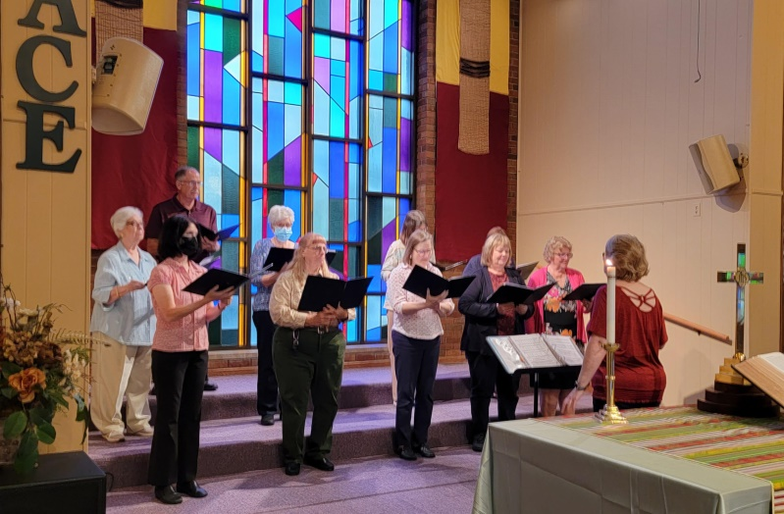

Grace United Methodist Church
1345 Chartres Street
LaSalle, IL 61301

Recipient Name
Street Address
City, ST ZIP Code

