Quotes from Henri Nouwen
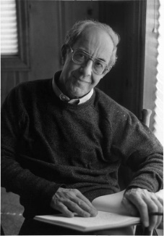“We tend to stay away from mourning and dancing. Too afraid to cry, too shy to dance...we become narrow-minded complainers, avoiding pain and also true human joy...While we live in a world subject to the evil one, we belong to God. Let us mourn, and let us dance.” ~Henri Nouwen

“One of the greatest ironies of the history of Christianity is that its leaders constantly gave in to the temptation of power even though they continued to speak in the name of Jesus, who did not cling to His divine power but emptied himself and became as we are.” ~Henri Nouwen

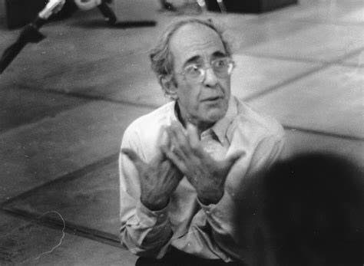"The way of Jesus is radically different. It is the way not of upward mobility but of downward mobility. It is going to the bottom...and choosing the last place! Why is [this] worth choosing? Because it is...the way that brings everlasting life." ~Henri Nouwen

“Do not despair, thinking that you cannot change yourself after so many years. Simply enter into the presence of Jesus as you are & ask him to give you a fearless heart where he can be with you. YOU cannot make yourself different.” Henri Nouwen,

