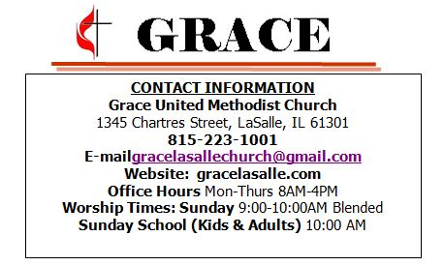
ATTENDANCE LAST WEEK
9:00 95
Weekly Giving Summary for the week of 01/19/20
Thank you all for the generous donations given to the church
We received $3.586.90
Donation Information for the Month of December
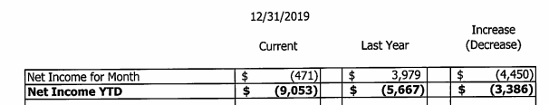

PRAYER CONCERNS
Lois Sheaff
Dick & Micki Graff
Dorothy Murphy
Jerry Davis
Polly Lawson
Amelia Nanni (Sister of Arnold Zolli)
Don & Ruth Kubberness

The Great Love
1 John 2:3-7
Order of Worship
Sunday, January 26th
9:00 AM

PRELUDE Linda Kardas

*OPENING HYMN Linda Kardas
Jesus Loves Me (Vs 1-3) Red #191

*OPENING PRAYER Pastor Brett

WELCOME & ATTENDANCE PADS
ANNOUNCEMENTS Pastor Brett

MISSIONS

JUST FOR KIDS Pastor Brett

CHANCEL CHOIR The Gift of Love

MESSAGE Pastor Brett
The Great Love

OFFERING Linda Kardas
OFFERING HYMN Red #344
Lord, You Have Come to the Lakeshore (Vs 1-3)

CLOSING HYMN Linda Kardas
All I Need us You (Vs1-3) Black#2080

*CLOSING Pastor Brett

*POSTLUDE Linda Kardas

ONGOING CLASSES/GROUPS/EVENTS
Tuesdays 9 AM & 6 PM Bible Study in the Café w/Pastor Brett
Wednesday 6:00 PM Prayer Shawl Ministry (Karen Swains)
Saturday - 9:00 AM Naomi's Friends, 1st Sat of the Month @ Country House

NOTICE! In the case of an emergency after hours, the best way to reach Pastor Brett is through his email at keltoi9@gmail.com

POTLUCKS- We will be holding monthly potlucks every 4th Sunday starting on Feb 23d, immediately after service. We will have a sign-up sheet outside the office if you are interested in bringing a dish or you can contact the office at 815-223-1001 or gracelasallechurch@gmail.com. Come join us for fabulous food and incredible Fellowship!

Ash Wednesday- Pastor Brett will be handing out Ashes in the Sanctuary on Wednesday, Feb 26th from 6 AM - 8 PM.

Dedication Plaques- A Memorial Plaque is a beautiful way to acknowledge and celebrate the life and legacy of a loved one. These beautiful plaques will be proudly displayed on the outside of the Tech booth wall. If you would like to order one of these plaques, we have order forms located in the hall outside the church office. Make Checks out to Grace UMC with Dedication Plaques in the Memo.

Scout Sunday is February 9th! - We invite you to wear your Scout uniform to be officially recognized, celebrated, and thanked for your support in Scouts!

RIPS FUNDRAISER- Summit will be holding their annual RIPS Chicken night Fundraiser on Monday, Feb 10th from 5-8 pm. Tickets 10.00 Each, ¼ chicken (light or dark meat), strips, fries, and bread. (No kids portions available). Dine-in or Carry-Out available. Tickets available at the Church Office or the Door.

Food Pantry- Please bring in Pasta for the food pantry cart this week
They are also in need of paper bags and plastic sacks.

Dry Pantry- Dry Pantry serves local families by providing supplemental groceries to people who cannot afford it. We need the following items for our Dry Pantry, Fruit, Veggies, and Soup, anything with a pop-top. Peanut Butter and Jelly, & Cereal.

Care Packages- Each bag may contain, among other things, a toothbrush, toothpaste, food, seasonal items, plus a Grace Church flier. We encourage you to keep one of these Care Packages in your vehicle. These bags are available in the Lobby. Please contact the office at 815-223-1001 for more information.

Welcome Bags: Missions Committee now has orange welcome bags at the entrance to the church for any newcomers. If anyone notices a new face at church please help us out by giving them one.

Bible Study - Join Pastor Brett Todd for this in-depth study of the Book of Acts!. This will be an exciting study, discussion, and reflection. Your understanding of the Bible and your faith will be opened and expanded! Bible Study held on Tuesdays, at 9 AM & 6 PM

Winter Warmth –With the temperatures dropping, Grace and Summit have re-opened our Winter Warmth Mission for the coming year. We have Winter Clothing available for those in our community that are in need. If you know of someone who needs Winter Wear, or If you would like to donate to this mission, we have a donation box located by the front door or you can contact the office at 815-223-1001. Because of your Generosity, we have helped more than 20 FAMILIES THIS SEASON with Winter Clothing. Thank you all for helping those in need with your generous donations!

Facebook & Website- If you haven't yet, Check out our Facebook and Web page! Feel free to share it with your friends and family!

MISSIONS MOMENT- Rainbow Covenant-Red Band. The GRACE Children’s Hospital and Pediatric Clinic, Port-au-Prince, Haiti, needs our support and our prayers. As the poorest country of the Western hemisphere, approximately 80% of Haitians live on less than $1 a day. The Delmas neighborhood of Port-au-Prince, where the hospital is located, is an area of great need for healthcare services. Families cannot afford the healthcare and, without Grace Children's Hospital, would have nowhere to turn. Children come in with a variety of diseases in addition to severe malnutrition. Our contributions help provide in-patient and out-patient care for children and families, as well as x-rays, medication, and lab availability for doctors. Can you help?

SUMMIT SUMMER PROGRAM- Summit will be holding its 1st annual Summer Program for children ages 2-5, June 8th - July 31st! If you are interested in more information or would like to register, you can email Summitlearning1345@gmail.com or call 815-780-7324

Finance & Executive Meetings- We will be holding our First Finance & Executive Committee meetings this monday, Jan 27th at 5:30 PM.

